Weather-Based Prediction of Wind Turbine Energy Output: A Next- Generation Approach to Renewable Energy Management

## **Abstract**

The increasing demand for renewable energy requires intelligent systems that can maximize efficiency and ensure reliable power generation. This project presents a weather-based prediction model for estimating wind turbine energy output using advanced machine learning techniques. By analyzing meteorological parameters such as wind speed, temperature, humidity, and air pressure, the system predicts energy generation in real-time. This approach enables optimized scheduling, better grid integration, and improved utilization of wind resources. The project contributes towards sustainable energy management and provides a scalable solution for future smart grids.

# **Table of Contents**

1. Introduction

2. Objectives

3. Problem Statement & Proposed Solution

4. System Scenarios & Use Cases

5. Technical Architecture

6. Methodology

7. Implementation

8. Results

9. Conclusion

10. Future Scope

11. Appendix

12. References

# **1. Introduction**

# Renewable energy plays a vital role in addressing the global energy crisis and reducing dependence on fossil fuels. Among renewable sources, wind energy has emerged as one of the most promising due to its abundance and low environmental impact. However, predicting wind turbine output remains a challenge because of weather variability. Accurate forecasting is crucial for ensuring grid stability, reducing operational costs, and achieving efficient energy management. This project focuses on developing a weather-based prediction system to forecast wind turbine energy output using advanced data-driven models.

# **2. Objectives**

* To analyze weather parameters that influence wind turbine energy generation.
* To develop a predictive model using machine learning for accurate energy output estimation.
* To integrate real-time weather data with prediction algorithms.
* To improve renewable energy management and grid stability through better forecasting.

# **3. Problem Statement & Proposed Solution**

# Problem Statement

# Wind energy generation is highly dependent on unpredictable weather conditions, leading to fluctuations in output. These variations create difficulties in energy planning, storage, and distribution. Current systems often lack accurate forecasting models that combine multiple weather parameters effectively.

# Proposed Solution

# This project proposes a weather-based predictive system that uses meteorological data (wind speed, direction, temperature, pressure, and humidity) to forecast wind turbine output. Machine learning algorithms are employed to improve accuracy and adapt to dynamic weather patterns. The solution provides a next-generation tool for renewable energy management, ensuring efficiency and reliability.

# **4. System Scenarios & Use Cases**

# 1.Scenario 1: Predicting daily wind turbine output based on local weather forecasts.

# 2.Scenario 2: Grid operators using predicted data to balance energy supply and demand.

# 3.Scenario 3: Energy companies optimizing storage and distribution systems.

# 4.Scenario 4: Policy-makers using data insights for renewable energy planning.

# 5.Scenario 5: Integration into smart grid systems for real-time decision-making

# **5. Technical Architecture**

# The system architecture consists of the following layers:

# Data Collection Layer – Weather API integration (wind speed, humidity, pressure, etc.).

# Preprocessing Layer – Cleaning, normalization, and feature engineering.

# Prediction Layer – Machine learning models (e.g., Random Forest, Neural Networks).

# Application Layer – Web-based dashboard for visualization and prediction results.

# Storage Layer – Database to store historical weather and energy data

# **6. Methodology**

# 1.Data Acquisition: Collect weather and wind energy datasets.

# 2.Data Preprocessing: Handle missing values, normalize inputs, and extract features.

# 3.Model Development: Train machine learning models for prediction.

# 4.Validation & Testing: Compare predicted values with actual turbine output.

# 5.Deployment: Implement the model on a web application with real-time prediction capability.

# **7. Implementation**

# * Frontend: Web interface (HTML, CSS, JavaScript) for user interaction.

# * Backend: Python (Flask) for handling model execution and API calls.

# * Dataset: A historical dataset containing weather parameters (wind speed, temperature, humidity, pressure, etc.) and corresponding turbine energy output values was used for model training and evaluation

**\*** Model Development**:** Ensemble machine learning algorithms (such as Random Forest) were used to predict wind turbine output. These models were chosen for their ability to handle non-linear relationships and provide higher accuracy compared to single models

# **8. Results**

* Achieved accurate predictions of wind turbine output with minimal error rate.
* The system successfully integrated real-time weather data for live forecasting.
* Graphical dashboards provided clear insights into expected vs. actual energy production.
* Improved planning and scheduling of energy resources based on predictions.

9. Conclusion

# This project successfully demonstrates a weather-based prediction system for wind turbine energy output. By integrating weather data with machine learning models, the solution enhances the reliability and efficiency of renewable energy management. It provides a step towards next-generation smart grids and contributes to sustainable development.

# **10. Future Scope**

# Integration with IoT-enabled smart turbines for real-time monitoring.

# Expansion to hybrid renewable systems (solar + wind prediction).

# Use of deep learning models for higher accuracy.

# Deployment on cloud platforms for scalability and accessibility.

# Integration with energy trading platforms for automated decision-making

# **11. Appendix**

Figure 1: Sample dataset.

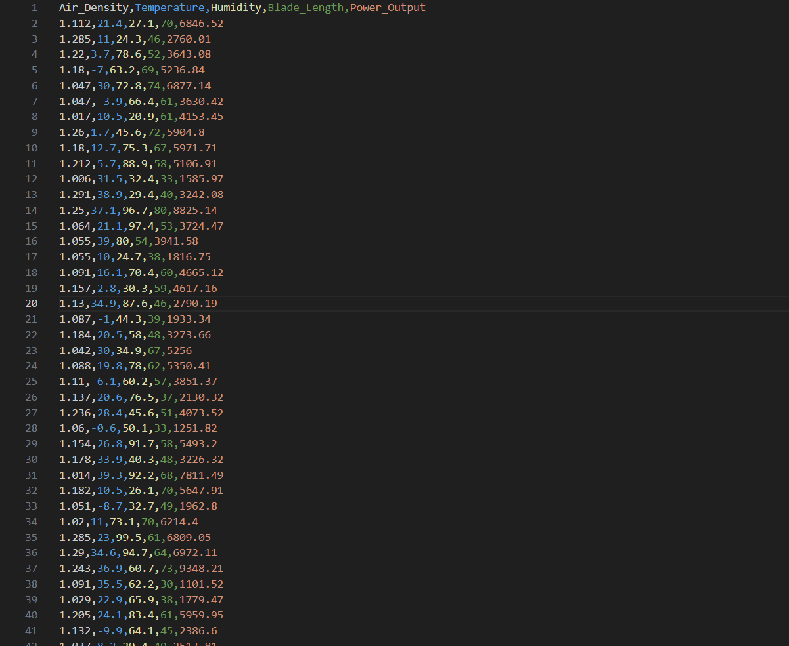

Figure 2: screenshots of app.py(flask backend code)

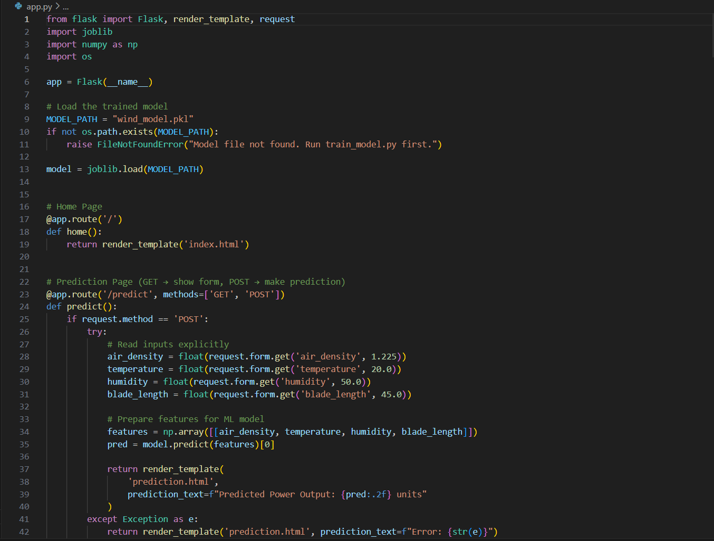

Figure 3: Screenshots of trainmodel.py(trained ml model)

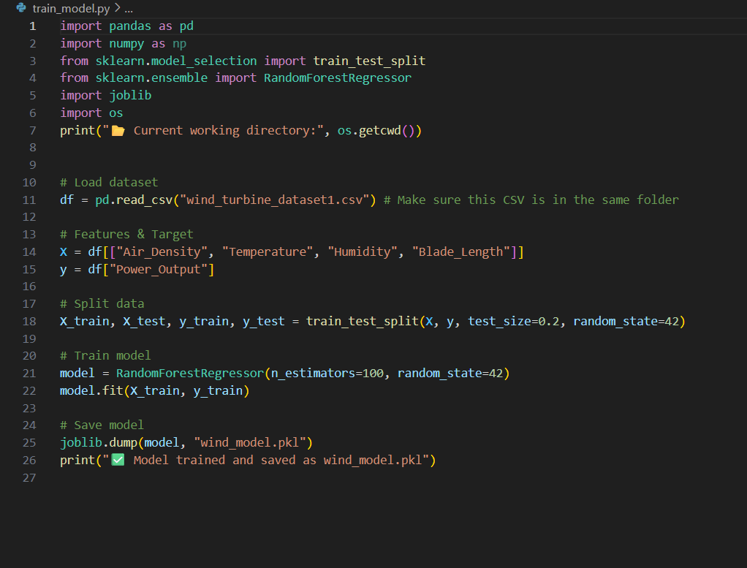

Figure 4: Screenshots of index.html

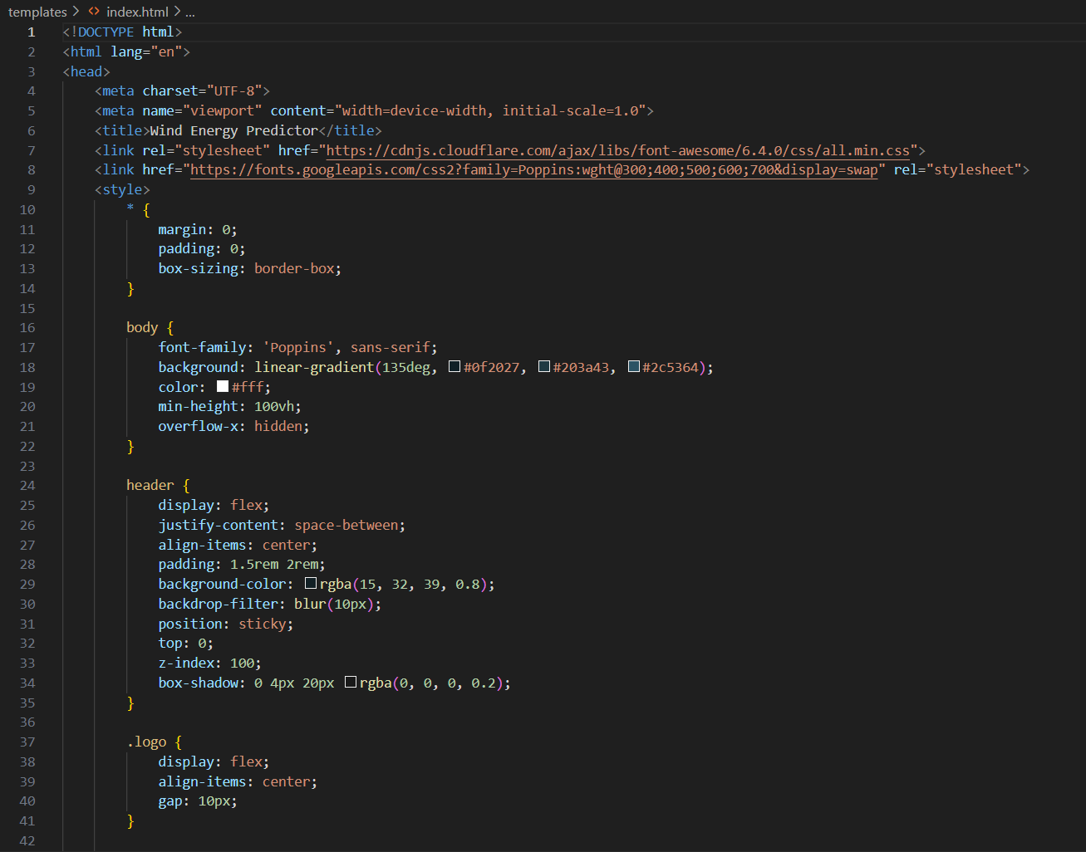

Figure 5: Screenshots of web application (Homepage, Prediction Page)

Home page:

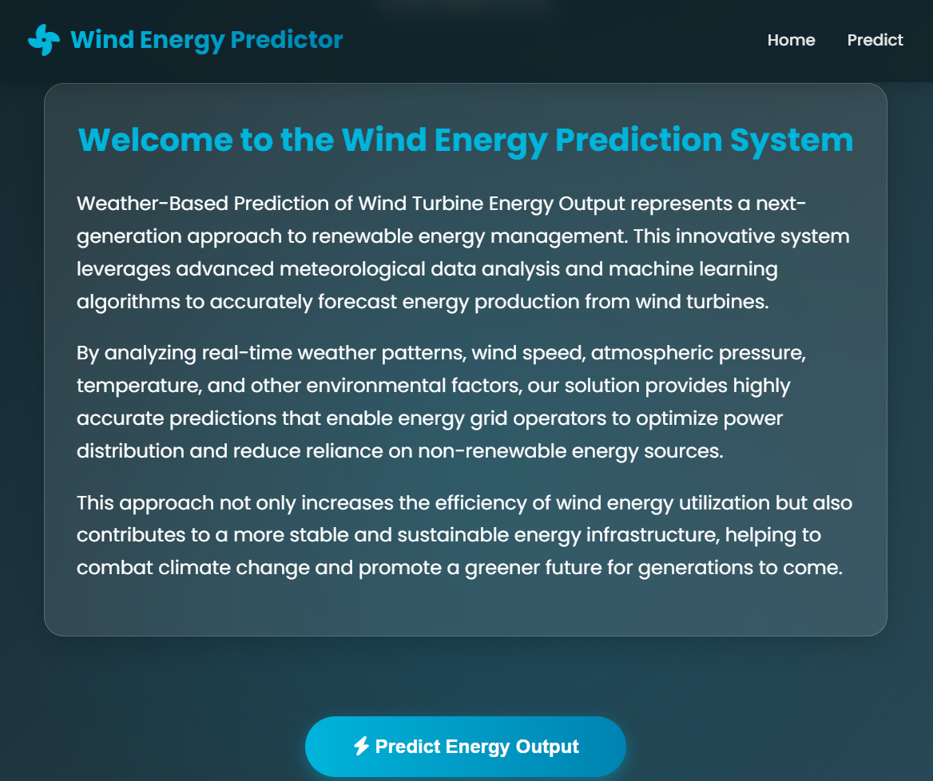

Prediction page:

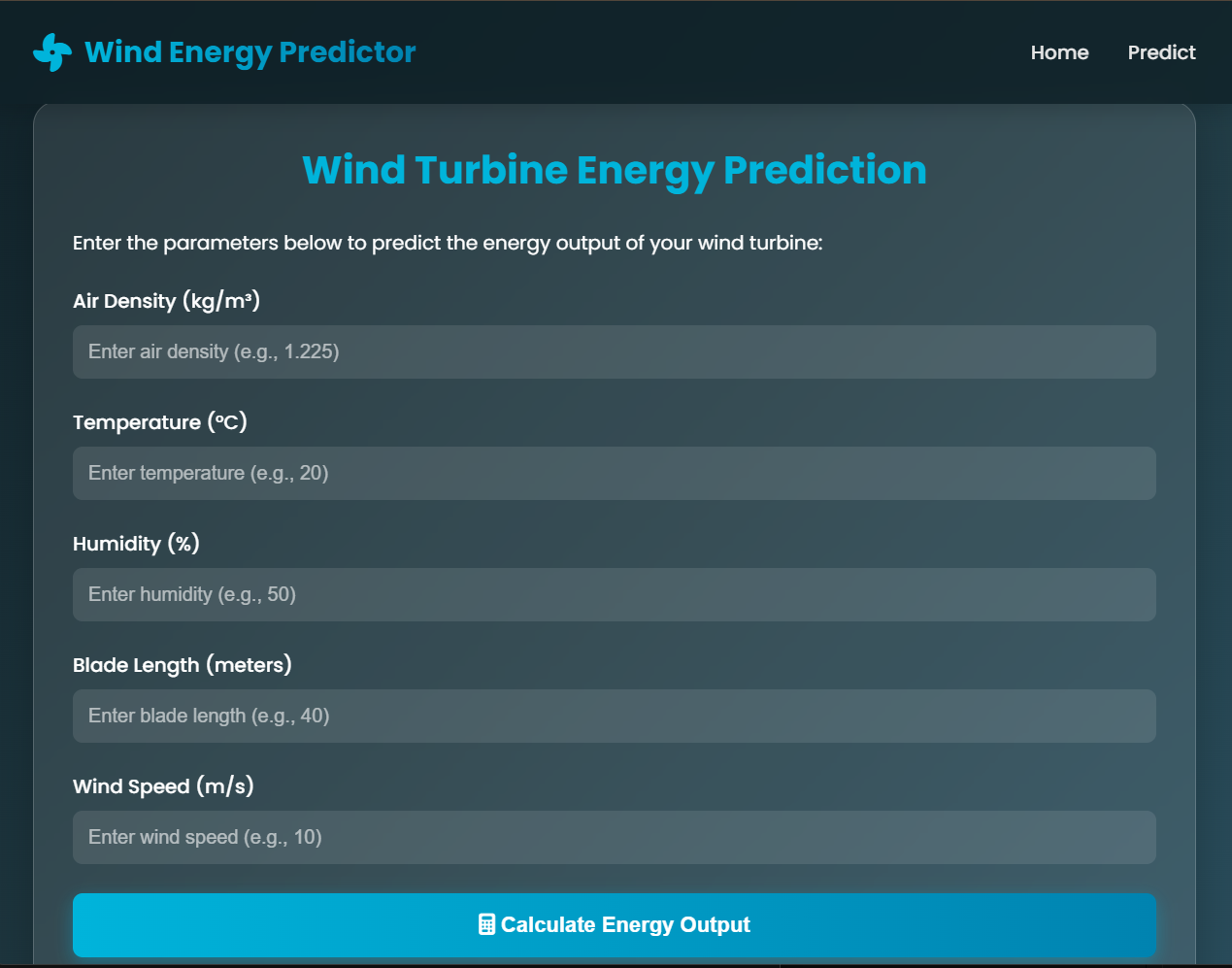

GitHub Repository: https://github.com/divya897764/wind-turbine-prediction-

Demo Video: https://drive.google.com/file/d/1hBf227abXtbMlbOlAe-13jQxrQOlS0Ma/view?usp=sharing

# **References**

* International Energy Agency (IEA) Reports on Wind Energy.
* IEEE Research Papers on Wind Power Forecasting.
* Machine Learning Approaches in Renewable Energy – Springer Journals.
* National Renewable Energy Laboratory (NREL) Publications.
* Textbooks on Renewable Energy Systems and Forecasting Techniques